Data in Machine Learning

Data is a crucial component in the field of Machine Learning. It refers to the set of observations or measurements that can be used to train a machine-learning model. The quality and quantity of data available for training and testing play a significant role in determining the performance of a machine-learning model. Data can be in various forms such as numerical, categorical, or time-series data, and can come from various sources such as databases, spreadsheets, or APIs. Machine learning algorithms use data to learn patterns and relationships between input variables and target outputs, which can then be used for prediction or classification tasks.
Data is typically divided into two types:
- Labeled data
- Unlabeled data
Labeled data includes a label or target variable that the model is trying to predict, whereas unlabeled data does not include a label or target variable. The data used in machine learning is typically numerical or categorical. Numerical data includes values that can be ordered and measured, such as age or income. Categorical data includes values that represent categories, such as gender or type of fruit.
Data can be divided into training and testing sets. The training set is used to train the model, and the testing set is used to evaluate the performance of the model. It is important to ensure that the data is split in a random and representative way.
Data preprocessing is an important step in the machine learning pipeline. This step can include cleaning and normalizing the data, handling missing values, and feature selection or engineering.
DATA: It can be any unprocessed fact, value, text, sound, or picture that is not being interpreted and analyzed. Data is the most important part of all Data Analytics, Machine Learning, and Artificial Intelligence. Without data, we can’t train any model and all modern research and automation will go in vain. Big Enterprises are spending lots of money just to gather as much certain data as possible.
Example: Why did Facebook acquire WhatsApp by paying a huge price of $19 billion?
The answer is very simple and logical – it is to have access to the users’ information that Facebook may not have but WhatsApp will have. This information about their users is of paramount importance to Facebook as it will facilitate the task of improvement in their services.
INFORMATION: Data that has been interpreted and manipulated and has now some meaningful inference for the users.
KNOWLEDGE: Combination of inferred information, experiences, learning, and insights. Results in awareness or concept building for an individual or organization.

How do we split data in Machine Learning?
- Training Data: The part of data we use to train our model. This is the data that your model actually sees(both input and output) and learns from.
- Validation Data: The part of data that is used to do a frequent evaluation of the model, fit on the training dataset along with improving involved hyperparameters (initially set parameters before the model begins learning). This data plays its part when the model is actually training.
- Testing Data: Once our model is completely trained, testing data provides an unbiased evaluation. When we feed in the inputs of Testing data, our model will predict some values(without seeing actual output). After prediction, we evaluate our model by comparing it with the actual output present in the testing data. This is how we evaluate and see how much our model has learned from the experiences feed in as training data, set at the time of training.
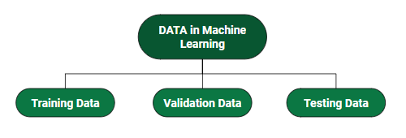
Consider an example:
There’s a Shopping Mart Owner who conducted a survey for which he has a long list of questions and answers that he had asked from the customers, this list of questions and answers is DATA. Now every time when he wants to infer anything and can’t just go through each and every question of thousands of customers to find something relevant as it would be time-consuming and not helpful. In order to reduce this overhead and time wastage and to make work easier, data is manipulated through software, calculations, graphs, etc. as per your own convenience, this inference from manipulated data is Information. So, Data is a must for Information. Now Knowledge has its role in differentiating between two individuals having the same information. Knowledge is actually not technical content but is linked to the human thought process.
Different Forms of Data
- Numeric Data : If a feature represents a characteristic measured in numbers , it is called a numeric feature.
- Categorical Data : A categorical feature is an attribute that can take on one of the limited , and usually fixed number of possible values on the basis of some qualitative property . A categorical feature is also called a nominal feature.
- Ordinal Data : This denotes a nominal variable with categories falling in an ordered list . Examples include clothing sizes such as small, medium , and large , or a measurement of customer satisfaction on a scale from “not at all happy” to “very happy”.
Properties of Data –
- Volume: Scale of Data. With the growing world population and technology at exposure, huge data is being generated each and every millisecond.
- Variety: Different forms of data – healthcare, images, videos, audio clippings.
- Velocity: Rate of data streaming and generation.
- Value: Meaningfulness of data in terms of information that researchers can infer from it.
- Veracity: Certainty and correctness in data we are working on.
- Viability: The ability of data to be used and integrated into different systems and processes.
- Security: The measures taken to protect data from unauthorized access or manipulation.
- Accessibility: The ease of obtaining and utilizing data for decision-making purposes.
- Integrity: The accuracy and completeness of data over its entire lifecycle.
- Usability: The ease of use and interpretability of data for end-users.
Some facts about Data:
- As compared to 2005, 300 times i.e. 40 Zettabytes (1ZB=10^21 bytes) of data will be generated by 2020.
- By 2011, the healthcare sector has a data of 161 Billion Gigabytes
- 400 Million tweets are sent by about 200 million active users per day
- Each month, more than 4 billion hours of video streaming is done by the users.
- 30 Billion different types of content are shared every month by the user.
- It is reported that about 27% of data is inaccurate and so 1 in 3 business idealists or leaders don’t trust the information on which they are making decisions.
The above-mentioned facts are just a glimpse of the actually existing huge data statistics. When we talk in terms of real-world scenarios, the size of data currently presents and is getting generated each and every moment is beyond our mental horizons to imagine.

Advantages Or Disadvantages:
Machine Learning theory is a field that intersects statistical, probabilistic, computer science and algorithmic aspects arising from learning iteratively from data and finding hidden insights which can be used to build intelligent applications. Despite the immense possibilities of Machine and Deep Learning, a thorough mathematical understanding of many of these techniques is necessary for a good grasp of the inner workings of the algorithms and getting good results.

**Artificial Intelligence (AI):**

**Definition:** Artificial Intelligence refers to the development of computer systems that can perform tasks that typically require human intelligence. These tasks include learning, reasoning, problem-solving, perception, understanding natural language, and speech recognition.

**Key Concepts:**
1. **Machine Learning:** A subset of AI that involves training models on data to make predictions or decisions without explicit programming.
2. **Natural Language Processing (NLP):** Enables computers to understand, interpret, and generate human-like language.
3. **Computer Vision:** Empowers machines to interpret and make decisions based on visual data.

**Applications of Artificial Intelligence:**

1. **Virtual Assistants:**
- *Siri, Google Assistant:* Provide voice-activated assistance, perform tasks, and answer queries.

2. **Healthcare:**
- *Diagnostic Assistance:* AI aids in medical image analysis and diagnosis.
- *Drug Discovery:* Accelerates the discovery of new pharmaceuticals.

3. **Autonomous Vehicles:**
- *Self-Driving Cars:* Use AI for navigation, object detection, and decision-making.

4. **Finance:**
- *Algorithmic Trading:* AI models analyze financial data for automated trading decisions.
- *Fraud Detection:* Identifies unusual patterns indicative of fraudulent activities.

5. **Education:**
- *Personalized Learning:* Adapts educational content based on individual student needs.
- *Automated Grading:* Streamlines the grading process using AI algorithms.

6. **Robotics:**
- *Industrial Automation:* Robots equipped with AI perform complex tasks in manufacturing.
- *Humanoid Robots:* Exhibit human-like capabilities for various applications.

7. **E-commerce:**
- *Recommendation Systems:* Suggest products based on user preferences.
- *Chatbots:* Enhance customer support and engagement.

8. **Cybersecurity:**
- *Threat Detection:* Uses AI to identify and respond to potential security threats.
- *Behavioral Analysis:* Monitors user behavior to detect anomalous activities.

9. **Natural Language Processing:**
- *Language Translation:* Translates text from one language to another.
- *Chatbots:* Conversational agents for customer support.

10. **Entertainment:**
- *Content Recommendations:* AI suggests movies, music, and other content based on user preferences.
- *Gaming:* AI algorithms enhance gaming experiences through intelligent opponents and adaptive gameplay.

11. **Smart Home Systems:**
- *Voice-activated Assistants:* Control smart devices using voice commands.
- *Energy Management:* AI optimizes home energy consumption.

12. **Social Media:**
- *Content Moderation:* Uses AI to identify and filter inappropriate content.
- *Face Recognition:* Tags individuals in photos and enhances user experience.

Artificial Intelligence continues to advance, transforming industries and impacting various aspects of our daily lives. Its applications are diverse and continue to expand as technology evolves.

**Machine Learning (ML)**:

**Definition:** Machine Learning is a subset of artificial intelligence that involves the development of algorithms and statistical models that enable computer systems to improve their performance on a task over time without being explicitly programmed. In other words, it's about machines learning from data and experiences.

**Key Concepts:**

1. **Training Data:** ML models learn from examples, and training data is crucial for their development.

2. **Algorithms:** ML algorithms are the mathematical instructions that guide the learning process.

3. **Predictions/Decisions:** Once trained, ML models can make predictions or decisions based on new, unseen data.

**Applications of Machine Learning:**

1. **Image and Speech Recognition:**

- *Facial Recognition:* Identifying and verifying individuals in images or videos.

- *Speech Recognition:* Converting spoken language into written text.

2. **Healthcare:**

- *Disease Prediction:* Predicting the likelihood of diseases based on patient data.

- *Drug Discovery:* Identifying potential new drugs and their effects.

3. **Financial Services:**

- *Credit Scoring:* Assessing creditworthiness of individuals.

- *Fraud Detection:* Identifying fraudulent activities in transactions.

4. **E-commerce:**

- *Recommendation Systems:* Offering personalized product recommendations.

- *Predictive Analytics:* Forecasting product demand and optimizing supply chains.

5. **Autonomous Vehicles:**

- *Object Detection:* Identifying pedestrians, vehicles, and obstacles.

- *Path Planning:* Navigating vehicles through traffic.

6. **Natural Language Processing (NLP):**

- *Chatbots:* Providing automated customer support.

- *Language Translation:* Translating text from one language to another.

7. **Manufacturing:**

- *Predictive Maintenance:* Anticipating equipment failures to reduce downtime.

- *Quality Control:* Identifying defects in products on the production line.

8. **Education:**

- *Personalized Learning:* Tailoring educational content based on individual student progress.

- *Automated Grading:* Speeding up the grading process using ML algorithms.

9. **Cybersecurity:**

- *Anomaly Detection:* Identifying unusual patterns indicating potential security threats.

- *Malware Detection:* Recognizing malicious software and preventing attacks.

10. **Social Media:**

- *Content Recommendation:* Suggesting posts, articles, or connections based on user preferences.

- *Sentiment Analysis:* Analyzing and understanding user sentiments from posts and comments.

Machine Learning continues to evolve, and its applications span across various industries, transforming the way tasks are automated, decisions are made, and insights are derived from data.

Advantages of using data in Machine Learning:
- Improved accuracy: With large amounts of data, machine learning algorithms can learn more complex relationships between inputs and outputs, leading to improved accuracy in predictions and classifications.
- Automation: Machine learning models can automate decision-making processes and can perform repetitive tasks more efficiently and accurately than humans.
- Personalization: With the use of data, machine learning algorithms can personalize experiences for individual users, leading to increased user satisfaction.
- Cost savings: Automation through machine learning can result in cost savings for businesses by reducing the need for manual labor and increasing efficiency.

Disadvantages of using data in Machine Learning:
- Bias: Data used for training machine learning models can be biased, leading to biased predictions and classifications.
- Privacy: Collection and storage of data for machine learning can raise privacy concerns and can lead to security risks if the data is not properly secured.
- Quality of data: The quality of data used for training machine learning models is critical to the performance of the model. Poor quality data can lead to inaccurate predictions and classifications.
- Lack of interpretability: Some machine learning models can be complex and difficult to interpret, making it challenging to understand how they are making decisions.
Use of Machine Learning :
Machine learning is a powerful tool that can be used in a wide range of applications. Here are some of the most common uses of machine learning:
- Predictive modeling: Machine learning can be used to build predictive models that can predict future outcomes based on historical data. This can be used in many applications, such as stock market prediction, fraud detection, weather forecasting, and customer behavior prediction.
- Image recognition: Machine learning can be used to train models that can recognize objects, faces, and other patterns in images. This is used in many applications, such as self-driving cars, facial recognition systems, and medical image analysis.
- Natural language processing: Machine learning can be used to analyze and understand natural language, which is used in many applications, such as chatbots, voice assistants, and sentiment analysis.
- Recommendation systems: Machine learning can be used to build recommendation systems that can suggest products, services, or content to users based on their past behavior or preferences.
- Data analysis: Machine learning can be used to analyze large datasets and identify patterns and insights that would be difficult or impossible for humans to detect.
- Robotics: Machine learning can be used to train robots to perform tasks autonomously, such as navigating through a space or manipulating objects.
Issues of using data in Machine Learning:
- Data quality: One of the biggest issues with using data in machine learning is ensuring that the data is accurate, complete, and representative of the problem domain. Low-quality data can result in inaccurate or biased models.
- Data quantity: In some cases, there may not be enough data available to train an accurate machine learning model. This is especially true for complex problems that require a large amount of data to accurately capture all the relevant patterns and relationships.
- Bias and fairness: Machine learning models can sometimes perpetuate bias and discrimination if the training data is biased or unrepresentative. This can lead to unfair outcomes for certain groups of people, such as minorities or women.
- Overfitting and underfitting: Overfitting occurs when a model is too complex and fits the training data too closely, resulting in poor generalization to new data. Underfitting occurs when a model is too simple and does not capture all the relevant patterns in the data.
- Privacy and security: Machine learning models can sometimes be used to infer sensitive information about individuals or organizations, raising concerns about privacy and security.
- Interpretability: Some machine learning models, such as deep neural networks, can be difficult to interpret and understand, making it challenging to explain the reasoning behind their predictions and decisions.

Machine Learning (ML) can be categorized into three main types based on the learning style and nature of the training data: supervised learning, unsupervised learning, and reinforcement learning.

### 1. **Supervised Learning:**
- **Overview:** In supervised learning, the model is trained on a labeled dataset, where the input data is paired with corresponding output labels. The goal is to learn a mapping function from input to output.
- **Key Characteristics:**
- The algorithm is provided with a labeled training dataset.
- The model makes predictions or decisions based on input features.
- The algorithm is corrected when its predictions are compared to the actual labels.
- **Applications:**
- **Classification:** Predicting the category or class of a given input.
- **Regression:** Predicting a continuous output or value.

### 2. **Unsupervised Learning:**
- **Overview:** Unsupervised learning involves training models on datasets without labeled outputs. The algorithm explores the inherent structure and patterns in the data, making it suitable for discovering hidden relationships.
- **Key Characteristics:**
- The algorithm is provided with an unlabeled dataset.
- The model identifies patterns, correlations, or structures in the data.
- Clustering and association are common tasks in unsupervised learning.
- **Applications:**
- **Clustering:** Grouping similar data points together based on features.
- **Dimensionality Reduction:** Reducing the number of input features while preserving relevant information.
- **Association:** Discovering rules that describe relationships within data.

### 3. **Reinforcement Learning:**
- **Overview:** Reinforcement learning involves training an agent to make sequences of decisions in an environment. The agent receives feedback in the form of rewards or penalties based on its actions, allowing it to learn optimal strategies over time.
- **Key Characteristics:**
- The algorithm interacts with an environment.
- The model learns by receiving feedback in the form of rewards or punishments.
- The objective is to maximize cumulative reward over time.
- **Applications:**
- **Game Playing:** Training agents to play games and improve their performance over time.
- **Robotics:** Teaching robots to perform complex tasks by trial and error.
- **Autonomous Systems:** Designing systems that learn from experience, such as self-driving cars.

### Additional Types and Hybrid Approaches:

#### 4. **Semi-Supervised Learning:**
- Combines elements of supervised and unsupervised learning.
- Uses both labeled and unlabeled data for training.
- Useful when obtaining labeled data is expensive or time-consuming.

#### 5. **Self-Supervised Learning:**
- A form of unsupervised learning where the algorithm generates its labels from the input data.
- Common in tasks like pretraining neural network representations.

#### 6. **Transfer Learning:**
- Involves training a model on one task and applying the learned knowledge to a different, but related, task.
- Can save computational resources and time.
### Conclusion:
Each type of machine learning has its strengths and weaknesses, and the choice depends on the nature of the problem and the available data. Supervised learning is prevalent in tasks with labeled data, unsupervised learning is useful for exploring patterns in unlabeled data, and reinforcement learning is applied when an agent interacts with an environment to learn optimal decision-making strategies. Hybrid approaches and specialized types of learning further enrich the ML landscape.
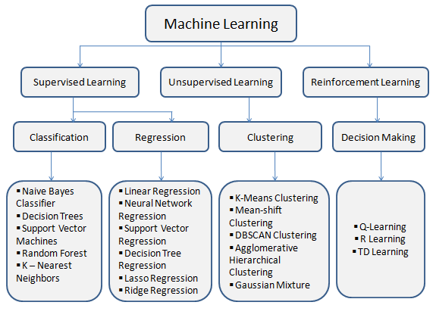
The machine learning process involves several key steps, from defining the problem and collecting data to deploying and maintaining the model. Here are the detailed steps of the machine learning lifecycle:

### 1. **Define the Problem:**
- Clearly articulate the problem you want to solve or the goal you want to achieve with machine learning.
- Understand the business context and define the success criteria for the project.

### 2. **Collect and Prepare Data:**
- Gather relevant data that will be used for training and testing the model.
- Clean and preprocess the data to handle missing values, outliers, and ensure consistency.
- Split the dataset into training and testing sets.

### 3. **Explore and Analyze Data:**
- Conduct exploratory data analysis (EDA) to gain insights into the dataset.
- Visualize data distributions, correlations, and patterns.
- Identify potential features that may be relevant to the problem.

### 4. **Feature Engineering:**
- Select and transform features to improve the model's performance.
- Create new features based on existing ones.
- Handle categorical variables through encoding techniques.

### 5. **Choose a Model:**
- Select an appropriate machine learning algorithm based on the nature of the problem (classification, regression, clustering, etc.).
- Consider factors such as model complexity, interpretability, and scalability.

### 6. **Train the Model:**
- Use the training dataset to fit the chosen model.
- Adjust model parameters to optimize performance.
- Evaluate the model's performance on a validation set to prevent overfitting.

### 7. **Evaluate the Model:**
- Assess the model's performance using metrics relevant to the problem (accuracy, precision, recall, F1-score, etc.).
- Use the testing dataset to ensure the model generalizes well to new, unseen data.
- Iteratively refine the model based on evaluation results.

### 8. **Tune Hyperparameters:**
- Fine-tune the model's hyperparameters to improve performance.
- Use techniques like grid search or random search to explore different hyperparameter combinations.

### 9. **Deploy the Model:**
- Integrate the trained model into a production environment for making predictions on new data.
- Implement proper monitoring to ensure model performance and detect potential issues.

### 10. **Monitor and Maintain:**
- Continuously monitor the model's performance in the production environment.
- Retrain the model periodically with updated data to maintain accuracy.
- Address any issues that may arise, such as changes in data distribution.

### 11. **Iterate and Improve:**
- Gather feedback from users and stakeholders to identify areas for improvement.
- Iterate on the model, data, or features based on feedback and evolving requirements.

### Conclusion:
The machine learning process is iterative, and each step is interconnected. The success of a machine learning project depends not only on the algorithm but also on thoughtful problem formulation, data quality, and ongoing monitoring and maintenance of deployed models.
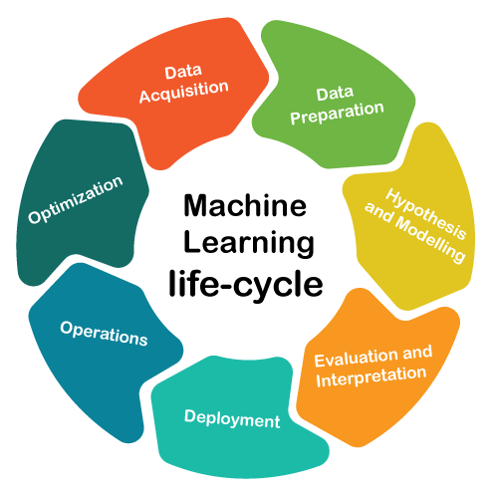
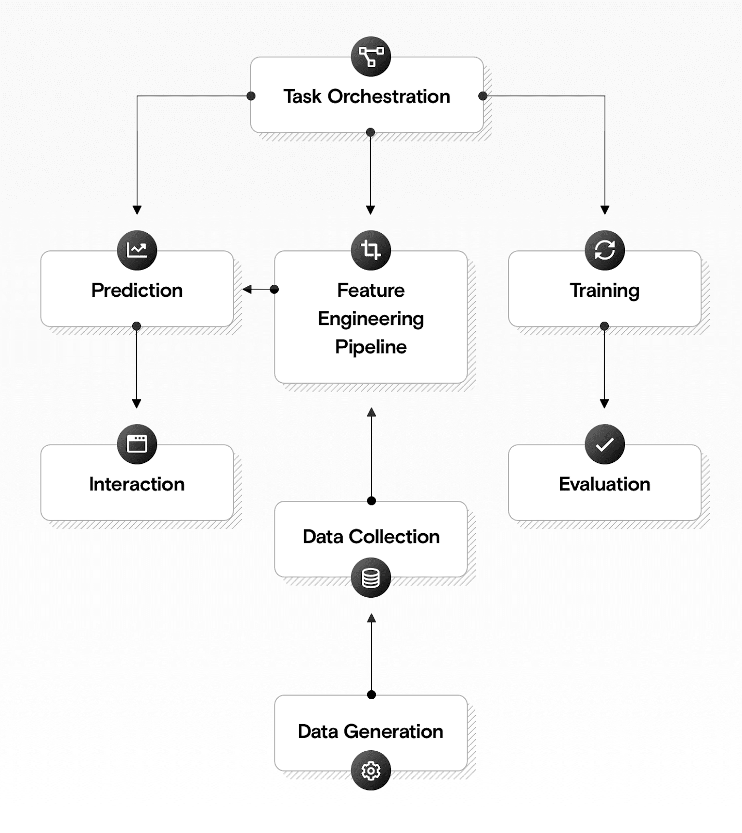
**Deep Learning:**

Deep Learning is a subset of machine learning that involves training artificial neural networks with multiple layers (deep neural networks) to perform tasks without explicit programming. Deep learning algorithms attempt to simulate the human brain's structure and function, enabling them to learn intricate patterns and representations from data.

**Key Concepts:**
1. **Neural Networks:** Basic building blocks of deep learning models, consisting of interconnected nodes (neurons) organized in layers.
2. **Deep Neural Networks (DNNs):** Networks with multiple hidden layers that allow the model to learn complex hierarchical representations.

**Applications of Deep Learning:**

1. **Image and Speech Recognition:**
- *Facial Recognition:* Identifying and verifying individuals in images or videos.
- *Object Detection:* Recognizing and classifying objects within images.
- *Speech Recognition:* Converting spoken language into written text.

2. **Natural Language Processing (NLP):**
- *Machine Translation:* Translating text from one language to another.
- *Chatbots:* Conversational agents for customer support and interactions.
- *Sentiment Analysis:* Analyzing and understanding sentiments in text.

3. **Healthcare:**
- *Medical Image Analysis:* Detecting and diagnosing diseases from medical images.
- *Drug Discovery:* Accelerating the identification of potential new drugs.

4. **Autonomous Vehicles:**
- *Object Detection:* Identifying pedestrians, vehicles, and obstacles.
- *Path Planning:* Navigating vehicles through traffic.

5. **Gaming:**
- *Game Playing:* Training agents to play complex games using reinforcement learning.
- *Character Animation:* Creating realistic and responsive in-game characters.

6. **Finance:**
- *Algorithmic Trading:* Analyzing financial data for automated trading decisions.
- *Credit Scoring:* Assessing creditworthiness based on extensive data.

7. **Retail:**
- *Recommendation Systems:* Offering personalized product recommendations.
- *Demand Forecasting:* Predicting product demand based on historical data.

8. **Cybersecurity:**
- *Anomaly Detection:* Identifying unusual patterns indicative of security threats.
- *Fraud Detection:* Recognizing fraudulent activities in transactions.

9. **Social Media:**
- *Content Moderation:* Filtering and moderating inappropriate content.
- *Image and Video Tagging:* Automatically tagging people or objects in multimedia content.

10. **Manufacturing:**
- *Predictive Maintenance:* Anticipating equipment failures to minimize downtime.
- *Quality Control:* Identifying defects in products on the production line.

11. **Research and Academia:**
- *Scientific Discovery:* Analyzing complex data in fields such as physics and biology.
- *Language Understanding:* Extracting knowledge from vast academic literature.

12. **Art and Creativity:**
- *Art Generation:* Creating visual and audio art using generative models.
- *Music Composition:* Generating music compositions with deep learning algorithms.

Deep learning has demonstrated remarkable success in various domains, particularly in tasks involving large datasets and complex patterns. As technology continues to advance, deep learning applications are likely to expand, contributing to further breakthroughs in artificial intelligence.

